Use Case Diagram

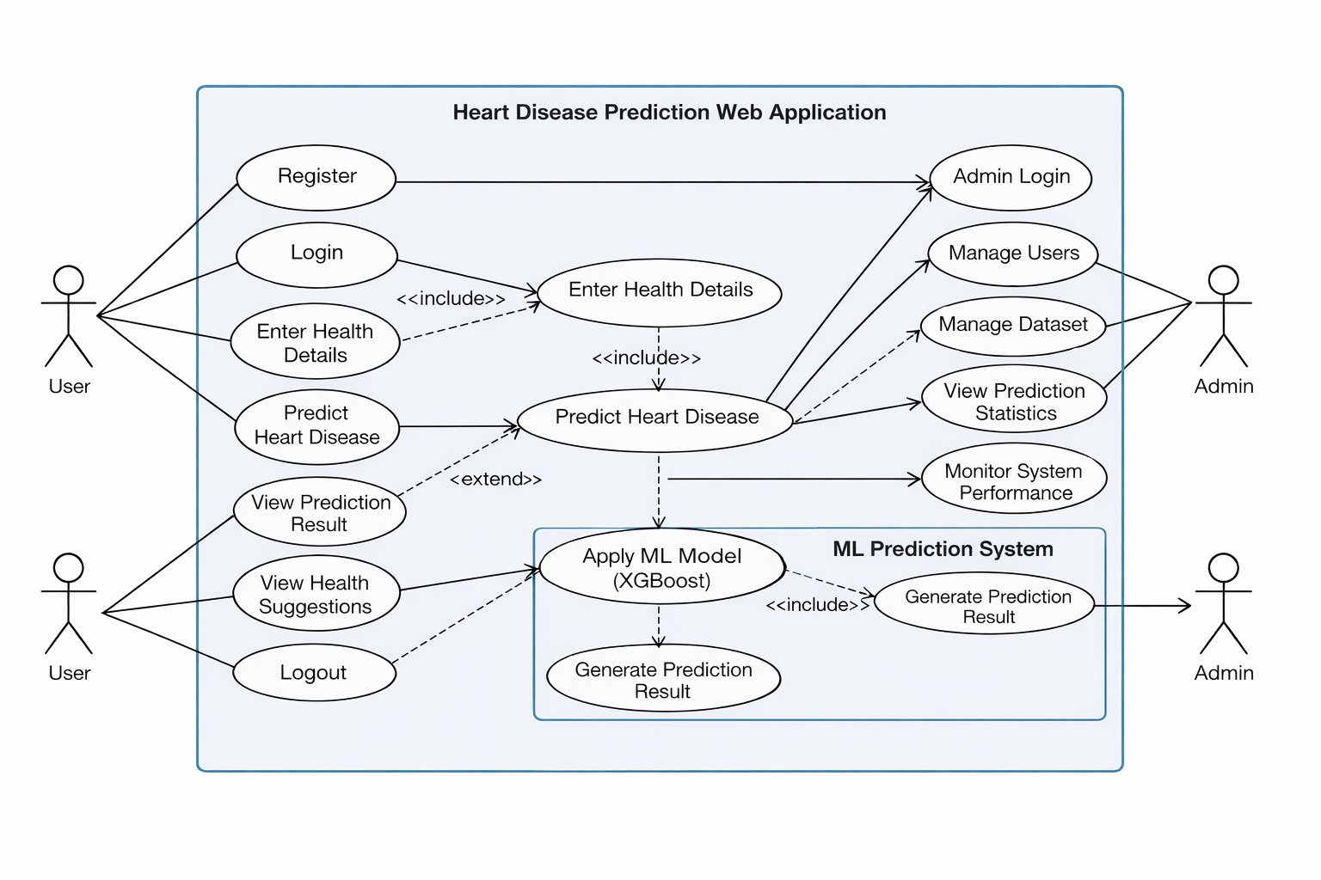
Figma link: https://www.figma.com/design/V301Sx3Nj6aeNqMx9H17cD/CVD?node-id=21-14&p=f&t=d3Yvn41LRrqtIJ8D-0

